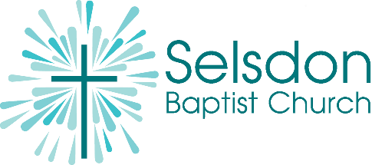

Selsdon Baptist Church Youth Activity Consent Form

Please complete this form and indicate which activities you are giving consent to for your young person to attend summer holiday activities from July to September 2026. The form must be completed in full by the young person’s parent or guardian. Please inform the youth team if any information changes.

I give permission for ________________________ (name) to attend:

Date: Tuesday | Activity | Sign and date each activity you give permission for. Leave blank any that you are not.
28 July | Bouldering at CroyWall, meet 2.00pm at church, travel by public transport to CroyWall, Whitestone Way, CR0 4WN. £10 for 1 hour session with instructors, including necessary equipment. Return to church by 5.00pm  Bring Zip Card/Oyster for travel on bus/tram | £10 payment required for this activity
04 August | Rounders in Selsdon Recreational Park  Meet 2.00pm at church, return to church at 4.00pm FREE
11 August | Soap and candle making at Selsdon Baptist Church 2.00pm-4.00pm FREE
18 August | Football skills in Selsdon Recreational Park  Meet 2.00pm at church, return to church at 4.00pm
25 August | Baking at Selsdon Baptist Church 2.00pm-4.00pm

Young Person's Full Name:

Young Person's Date of Birth:

School Name & Year:

Home address:

Parents/Carers Names:

Contact Number:

Email Address:
Would you be happy to be a part of a 'Selsdon Baptist Church Parent/Carers WhatsApp group' to receive weekly updates of what's going on for young people at church? If so, please circle:
Yes No
Young Person's GP Name and Address:

GP Telephone Number:

Does the young person have any medical conditions we should be aware of?

Does the young person take any medication? (If they need inhalers or an EpiPen with them on a trip
please ensure they bring them with them)

Does the child/ young person have any disabilities or special needs that we should be aware of?

Anything else you would like us to know:

I give permission for the child to be photographed within groups and that the pictures may be used for internal and external uses within Selsdon Baptist Church platforms.
(Please circle) Yes/ No/ Other

The information you provide on this form will be stored securely. We will NOT pass on this information to anyone else. You have the right to ask to be removed from this at any time. If you are concerned about the way your information is being handled, please speak to our data protection officer. If you are still unhappy you have the right to complain to the information commissioner’s office.

